Role Title: Business Analyst |  | Date: October 2024
Role Grade: C  Reports To: Lead Business Analyst |  | Business Unit: Technology Delivery
Role | Need to Do | Need To Know | Need to Be
Function Purpose:  - To develop Business Requirements and viable Business Solution Designs.  - Ensure that the assets produced are appropriate for re-use in line with RAC business strategy and IT architecture.  - To consider the needs of:  - The business and our strategy to become the motorists’ champion  - The customer and be prepared to challenge decisions that are not in their best interests as defined by our customer ambition and the principles of TCF.  - Understand and communicate the value of the Business & CPTO Divisional Strategy and considering process, people and technology.  Breadth & Depth of Role:  - Accountable for providing the programme/project with business and technical expertise, to shape the delivery, providing appropriate solution options and estimates to deliver business outcomes.  - Assignments will be moderately complex and might be across a programme or project(s), typically less than £1m.  Relationships:  - Strong relationships across the programme/ project working with Sponsors, Project Managers, Engineering team, Test Team, other BAs, Solution Architects and Product Owners.  - Strong relationships with external suppliers  - Practice working groups, technical forums and technical design authorities. | Key Role Responsibilities:  Defining, analysing and documenting requirements and processes to show what the solution will do but not how it will be done – representing a model of the system to serve as an intermediate step between the business need and the technical solution design.  During requirements gathering and analysis:  - Studying requirements feasibility to determine if the requirement is viable technically, operationally and economically (cost/benefit analysis)  - Assessing requirements feasibility by analysing requirement risks and constraints, modifying requirements to mitigate identified risks  - Prioritising requirements to reflect the fact that not all requirements are of equal value to the business, but finding ways to ensure that multiple parties can meet their own goals and interests (win-win situations) - promoting collaboration and discouraging an ‘us’ versus ‘them’ approach  - Taking responsibility for resolving project conflicts or disagreements  - Validation and verification of requirements throughout a project to ensure that the system/solution satisfies the requirements  - Where appropriate challenging subject matter experts, to ensure requirements are aligned to the scope, objectives and critical success factors of the project  Undertaking feasibility studies and impact analyses to:  - Support strategic planning and validate business need  - Provide possible solution options for consideration  - Enable business and project decisions to be reached  Defining and documenting business solution designs that incorporates the ‘to be’ business processes to support business readiness and delivery including testing and training  Ensuring that new services are successfully introduced into production with the right support | Key Skills  - Problem solving, negotiation and decision-making skills are essential  - Stakeholder management and effective communication to accommodate different social styles and communication preferences  - Proven ability to deliver solutions for programmes/ project(s) balancing time, cost and quality  - Organisational skills including both time and workload management  - Ability to self-manage own time and tasks  - Ability to run workshops  Knowledge  - Ideally BCS qualified (Int. Diploma in BA) or working towards qualification  - Basic knowledge of the insurance industry regulation and legislation (FCA / TCF)  - Detailed knowledge of requirements definition; requirements management, solution processes and associated techniques in line with waterfall or agile developments  - Knowledge of the end-to-end delivery project lifecycle  Experience  - Minimum 2 years Business Analyst experience  - Waterfall project delivery or methodology experience  - Knowledge of Agile delivery methodologies | 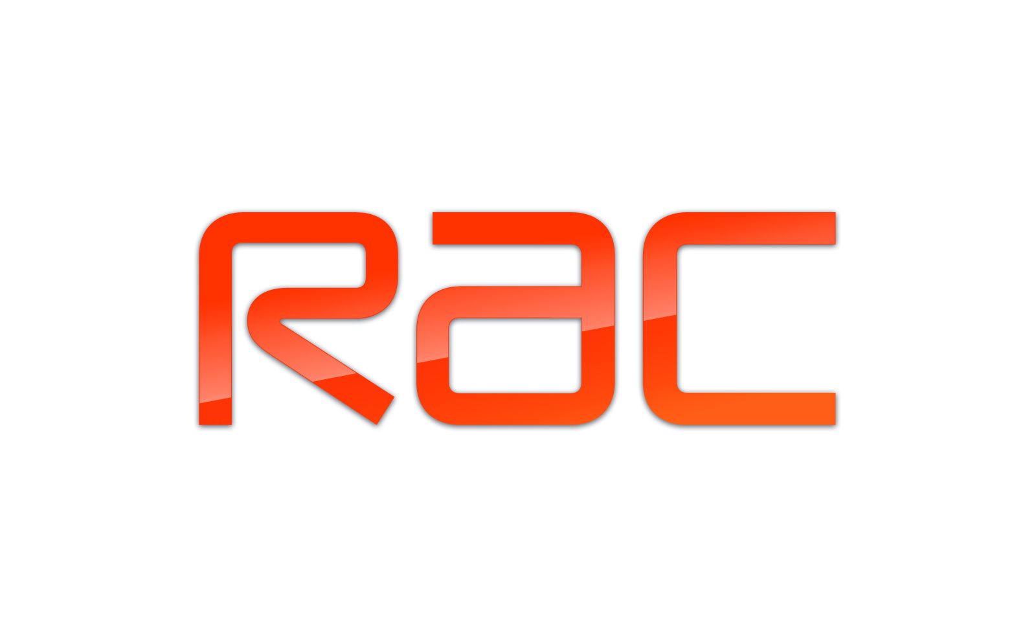  Core Competencies:  - Interpersonal & Influencing skills (Level 3)  - Judgement & Decision Making (Level 2)  Commercial Awareness (Level 2)  Leading Change (Level 3)  - Achievement & Drive (Level 3)  Customer Focus (Level 3)  Behaviours consistent with RAC core values  Demonstrates all-round behaviours that fit with our core values:  Handle It Together  - Acts with integrity and fairness  - Shares ideas and works across functions  - Demonstrates courage to challenge others  Exceptional Service  - Keeps customer and colleague at the heart of what they do  - Goes the extra mile  - Understands and champions RAC and Technology strategies  Raise the Bar  - Ambitious to improve self  - Sets stretching targets  - Continuous learning and shares learning  Own It  - Leads by example  - Trusted to achieve outcomes  - Passionate and committed

