Role Title: SMR Learning & Development Specialist Date: March 2025
Grade: B Business Unit: Service Maintenance and Repair
Role | Need to Do | Need To Know | Need to Be
Role Summary:  - To design, deliver and evaluate dynamic development solutions, aligned to the learning cycle for colleagues across SMR Contact Centre teams  - Ensure all training is aligned with business objectives and focussed on efficiently providing an exceptional customer experience  - Complete QA assessments, provide feedback and develop training solutions to address knowledge gaps  - Delivery of core learning and development offer, including Induction Training for all new CC colleagues  - Design and delivery of new training and development interventions aligned with the SMR Business Plan, covering process change and campaign activity  - Develop and maintain a learning library, where all learning material is accessible  - Promote and maintain knowledge management tools, and ensure adoption supports quality customer outcomes  - Ensure continuous self-learning is adopted for SMR products & services, aligning to industry best practice.  - Bescot office based  - Requirement to work flexibly `between 8am and 6pm, and undertake ad-hoc duties as required by the demands of the business.  Reports to:  Contact Centre Manager  Relationships  Internal:  - Contact Centre Leadership Team  - SMR Operations Team  - Peer Group in HR, Recruitment & Training  - Wider business QA community  - Customer Care team  External:  - Outsourced partners  - Any 3rd party consultants engaged, specialising in training & development.  - CIPD | Outcomes:  - As ‘the face’ of SMR, act as a role model displaying best practice in terms of performance and behaviours, leading by example always to shape expectations for all colleague delegates.  - Deliver / facilitate training to new and existing colleagues across multiple disciplines; aligned with the training plan and quality targets  - Ensure colleagues entering training have all relevant assets/system accesses and are trained how to use it  - Work with all business areas to identify training and development needs and to design appropriate learning solutions to meet those needs  - Design and deliver training packages, utilising all available options and accommodating different learning styles  - Develop ad-hoc training solutions to meet evolving business needs e.g. initiatives, systems or product training  - Maintain, evolve and improve existing training materials in line with industry best practice/RAC/SMR policy frameworks  - Research and introduce new training tools exploiting technology to maximum advantage which supports a blended approach to learning  - Build and maintain effective working relationships with CC management team to ensure a seamless learning experience for colleagues as they move from classroom to role  - Developing effective cross-functional relationships within the RAC and external partners in order to support effective stakeholder management  - Actively take responsibility for day to day decisions relating to enhancement of colleague development  - Completion of administrative tasks associated to the role including preparation/required documentation  - Using own initiative to assist in identifying areas requiring additional support, offering coaching and training solutions through closely working with data relating to complaints/feedback  - To continuously and effectively evaluate all learning programmes, and ensure they meet business needs in terms of benefits  Take responsibility for your own approach to self-learning, which ensures your own specialist knowledge of SMR process, products, offers, performance, customer service skills, competitor activity and future business roadmap are continually kept up to date and accurately reflect the business focus and goals | Skills/Knowledge/Experience:  - Outgoing/confident individual with a positive ‘can do’ attitude  - Passionate about developing others with a good understanding of ‘how people learn’  - Experience of delivering/facilitating training, preferably within a contact centre environment  - Experience of developing and implementing training solutions..  - An experienced Coach with proven ability to deliver feedback in a positive, enthusiastic and constructive manner.  - Can demonstrate effective stakeholder management skills  - Excellent organisational skills including time management with willingness to accept ownership and accountability of work.  - Must ensure all outputs are completed with accuracy and attention to detail, whilst working quickly and accurately to tight deadlines.  - Excellent communication skills, both written and verbal with the ability to work effectively and interact with colleagues across all RAC business areas whilst having a strong Business and operational understanding.  - Tolerance of ambiguity, resilience and patience to work within a pressured environment.  - Demonstrate a drive and desire to make an impact upon the business.  - Ability to work in individually and as part of a wider team  - Proven track record in acting as a role model  - In-depth knowledge of MS Office software  Qualifications:  - CIPD/TAP’s qualified (or studying towards) is preferred | 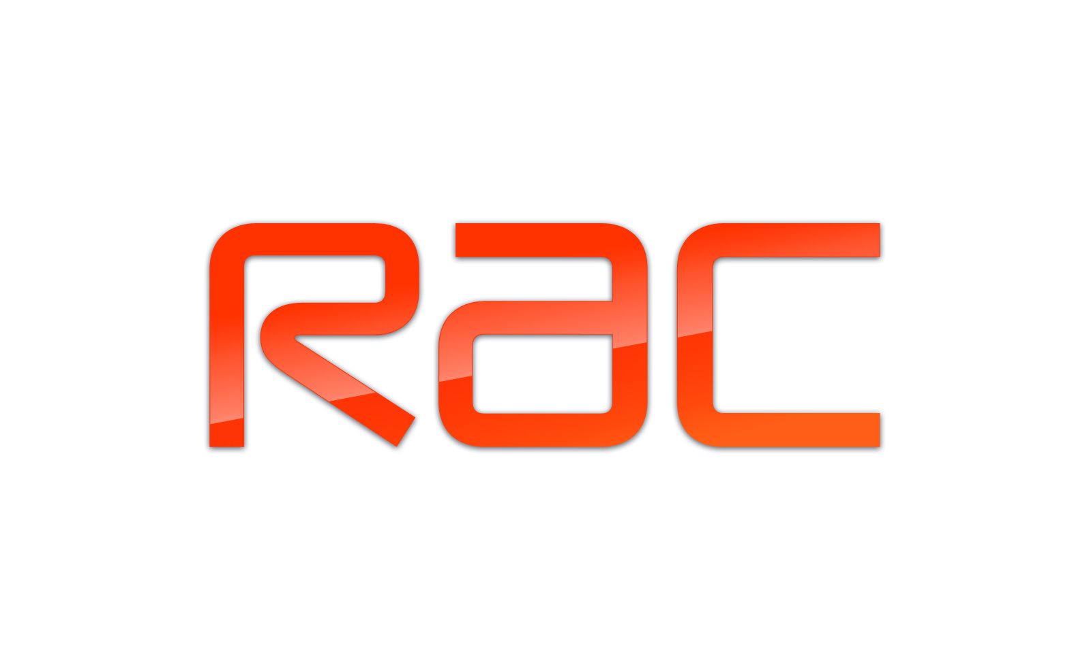  Capabilities/Strengths:  Need to exhibit behaviours consistent with RAC core values:  - Handle it together  - Exceptional Service  - Raise the Bar  - Own It  Core Competencies  - Customer focus Level 3: Anticipates and response to customers changing needs and expectations  - Developing Self & Others Level 3: Understands what is required for career development & gives support to others in theirs.  - Interpersonal & Influencing Skills Level 3: Has the personal skills and capability to influence a broad range of people including key decision makers.  - Achievement Drive Level 3: Accepts change, is flexible and applies sustained energy in order to adapt to new requirements  - Team Working Level 3: Understands how and when to set team goals and objectives and makes use of the skills and talents of team members.  - Continuous Improvement Level 3: Closing the loop between customer feedback and colleague performance.

